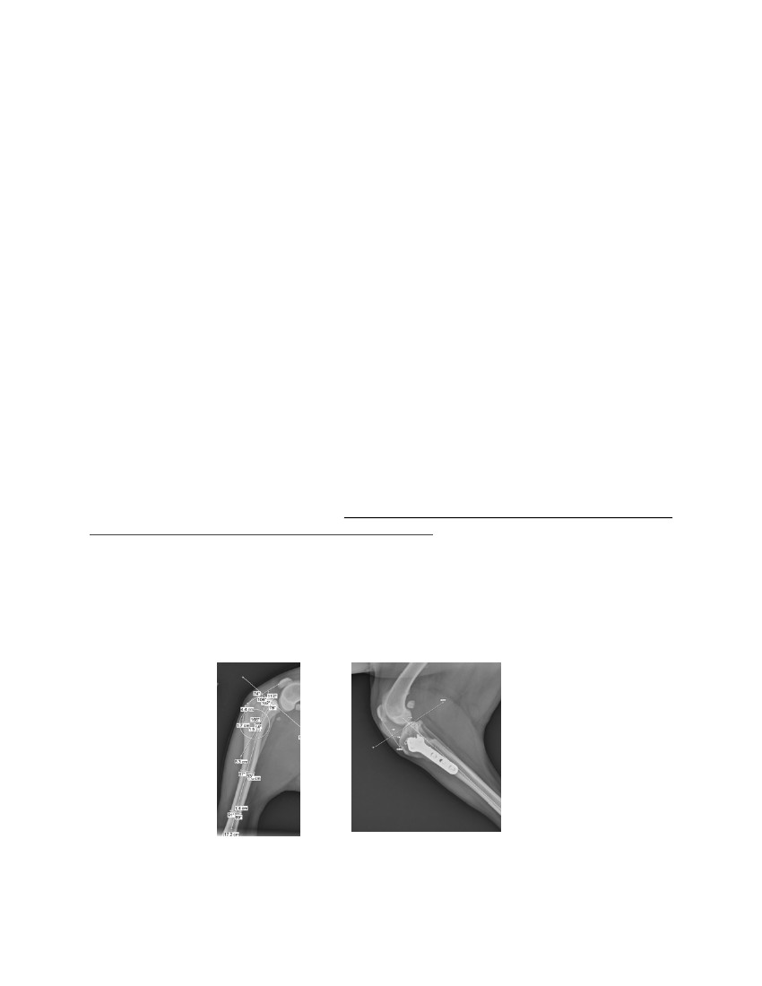
CORA BASED LEVELING OSTEOTOMY FOR TREATMENT OF THE CCL
DEFICIENT STIFLE
Don Hulse DVM, Diplomate ACVS, Brian Beale DVM, Diplomate ACVS,
Mike Kowaleski DVM, Diplomate ACVS
Texas A&M University, College Station, Texas
Tibial plateau leveling osteotomy (TPLO) is a popular method for treating the CCLD
(CCL Deficient) stifle joint in the dog. Recent studies have shown significant joint mechanical
alteration which may be contributory to articular cartilage lesions. One explanation for reported
abnormal joint mechanics is that the standard Slocum osteotomy is not based on the mechanical
or anatomic CORA. As such, the Axis of Correction (ACA) is not aligned with the CORA
resulting in mal-alignment of the anatomic/mechanical axis and secondary translation. The result
is caudal displacement of the weight bearing axis and a focal increase in joint force. Further,
TPLO creates a caudal thrust. The long term effect of caudal thrust is loss of compliance of
cranial supporting structures such as the fat pad and joint capsule. Encroachment of the cranial
supporting structures (joint capsule) on the cranial articular surface of the medial/lateral femoral
condyles can result in abrasion of the articular cartilage.
The subject of this presentation is to report the concept and technique of a tibial plateau
leveling osteotomy based on the anatomic CORA. The concept is supported by anatomic
dissection, radiographic analysis of treated cadaver specimens, and application in clinical cases
having ligament injury to the stifle (55 cases). Clinical cases include those with multiple
ligament injury, acute complete CCL injury with marked craniocaudal and rotational instability,
partial stable CCL injury, and partial unstable CCL injury. Clinical outcome, complications
unique to the technique, and strategies to prevent complications will be addressed.
Goals of the technique include: 1. preservation of the proximal tibial epiphysis which
allows for application of ancillary stabilizing procedures. The location of the anatomic CORA is
such that an osteotomy can be performed which preserves the anatomy of the proximal tibial
epiphysis. An intra-articular reconstruction using bone tunnels or the under and over technique is
readily accomplished. Likewise, if the attending surgeon wishes to apply an extra-articular
stabilizing procedure it is easily accomplished with the ample bone target of the proximal tibial
epiphysis following rotation. The authors have used isometric placement of Fibertape with a
Swivelock or IA reconstruction with an autogenous graft.
Pre op and 12 week PO Images of a Labrador having multiple ligament injury stabilized
with a CORA based osteotomy and an Arthrex SwiveLock loaded with 2mm FiberTape
516
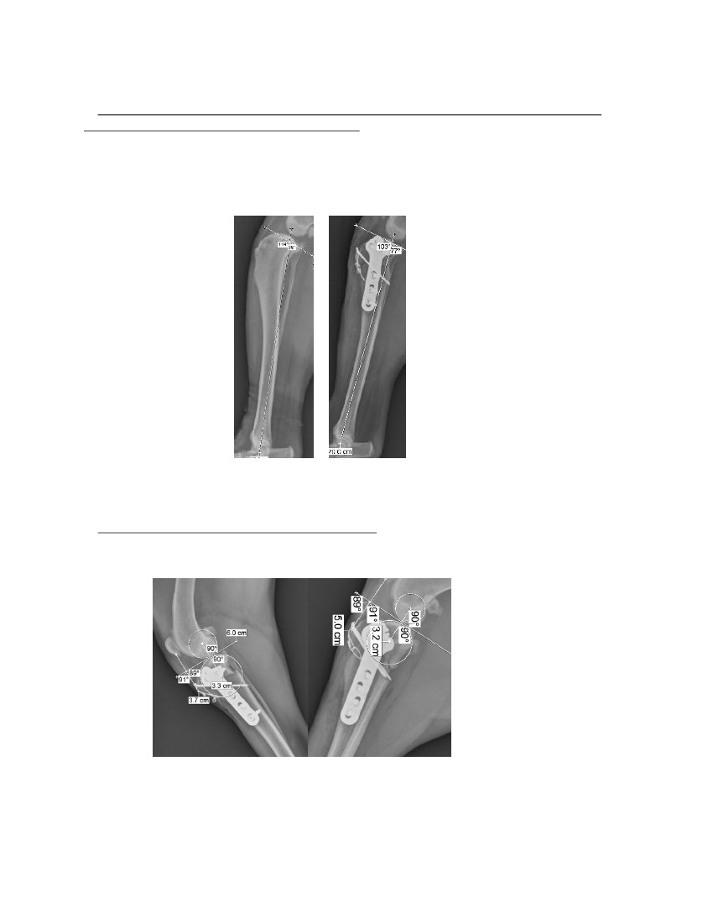
2. Alignment of the proximal and distal segment anatomic/mechanical axis and maintaining
approximately 30 % of the normal cranial thrust.
CORA based osteotomy aligns the anatomic/mechanical axis following rotation. The
femoral condyles appear “centered” on the tibial plateau following rotation. The hypothesis is
that this will maintain normal stress distribution and kinematics of the stifle.
Image of a dog with 24 degree TPA pre op and 13 degree TPA post op showing alignment
of the anatomic/mechanical axis.
3. Establish 90 degree plateau/patella tendon angle. An additional advantage of CBLO is that
the technique appears to simulate a TTA in that post operatively the patella tendon (PTA) / tibial
plateau slope (TPA) angle is approximately 90 degrees.
Post op images of two cases showing measurement of the tibial plateau slope/patella tendon
angle
517
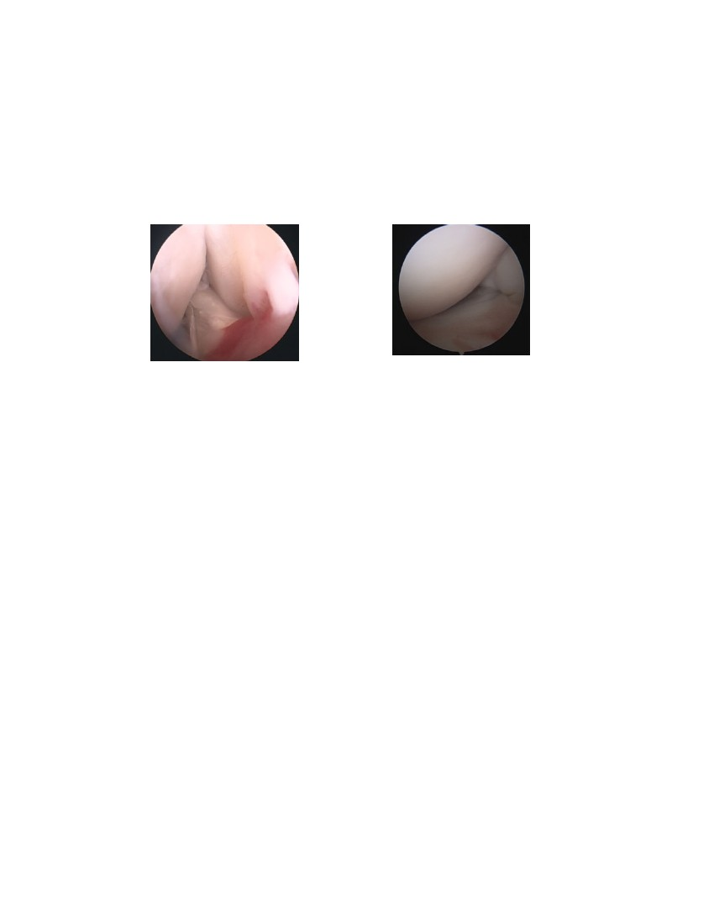
Recommended rotation of the TPA is to 12-14 degrees rather than 5 degrees as with the
standard TPLO. Rotation to this slope reduces the stress on an intra-aticular autograft/allograft or
stabilizing suture (FiberTape, FiberWire) by approximately 65%. This helps preserve the
integrity of the stabilizing procedure maintaining long term stability. Additionally, rotation to 12-
14 degrees does not generate a caudal thrust as seen with a standard TPLO. The hypothesis is
that by eliminating posterior thrust, one will eliminate the cranial abrasion lesions seen with
TPLO.
IA graft 8 weeks PO
Medial joint line 12 weeks PO
518

