Radiographic Healing Following Stabilization of Cranial Cruciate Ligament Deficient Stifles with a CORA-Based Leveling Osteotomy (CBLO), Bone Plate/Headless Compression Screw Construct Augmented with a Tension Band
Tiffany A. Johnson, DVM¹, Elizabeth M. Krier, DVM¹, Don A. Hulse, DVM, Diplomate ACVS & ECVS^{1,2}, Laura E. Peycke, DVM, MS, Diplomate ACVS & ACVSMR², Brian Beale, DVM, Diplomate ACVS³, Caleb Hudson, DVM, Diplomate ACVS³, Gary T. Old, DVM⁴
¹Austin Veterinary Emergency and Specialty Center, Austin, TX, ²Texas A&M University College of Veterinary Medicine, College Station, TX, ³Gulf Coast Veterinary Specialists, Houston, TX, ⁴Richmond Road Animal Hospital, Texarkana, TX

ABSTRACT:
Objective: The purpose of this study is to document osseous bridging of the osteotomy and TPA at 35 days post-operatively (range 25–40 days) following stabilization of cranial cruciate ligament (CrCL) injury with a CORA-based leveling osteotomy (CBLO) using a bone plate/headless compression screw (HCS) construct augmented with a tension band.
Study Design: Prospective case series
Animals: Dogs (n = 47)
Methods: Medical records from May 2017 to February 2018 of dogs diagnosed with CrCL injury treated with a CBLO stabilized with a bone plate and HCS augmented with a tension band were reviewed. To be included, signalment and appearance of intra-articular structures must be available. Median score of radiographic osseous bridging of the osteotomy¹⁻⁴ assessed by 5 independent reviewers 35 days postoperatively were recorded. Preoperative TPA, postoperative TPA, and final TPA were recorded.
Results: Forty-seven dogs (49 stifles) met the inclusion criteria. Both sexes and 13 breeds were represented. Mean age was 6 years (range 1.5–11 years); mean body weight of 32 kg (range 5.2–53.6 kg). All dogs had a complete CrCL tear. Mean PreTPA was 30º (20º – 44º), mean PostTPA was 9º (5º – 14º), and mean FinalTPA was 9º (5º – 14º). No dog had an increase in final TPA as compared to postoperative TPA. Osseous bridging of the osteotomy was a median of grade 4 in 38 stifles (78%) and a median of grade 3 in 11 stifles (22%).
Clinical Relevance: Improved stabilization of a CBLO will enable earlier osseous bridging and prevent TPA shift.

INTRODUCTION:
Cranial cruciate ligament (CrCL) injury leads to stifle instability and is a primary cause of hind limb lameness in dogs. Two common osteotomy procedures used for stabilization of the CrCL deficient stifle are the Tibial Plateau Leveling Osteotomy (TPLO) and the CORA Based Leveling Osteotomy (CBLO).¹⁻⁸ The CBLO procedure involves a proximal tibial leveling osteotomy based on the center of rotation of angulation (CORA)⁵⁻⁶. When the axis of correction (center of the saw blade) is centered at the CORA, correction of the CORA magnitude results in the desired tibial plateau angle (TPA) without secondary translation.^{6,7,9-12} When translation is prevented, the amount of bone contact across the osteotomy is maximized. This coupled with the ability to apply compression across the osteotomy leads to early return to function and bone union¹⁻².
Previous studies evaluating radiographic osteotomy site healing for the CBLO/TPLO procedures recommend final radiographic assessment at 8-12 weeks following surgery.^{1-4,8} Kishi et. al.² showed that at a median time of 63 days (range 32 – 424 days) following surgery, 69% of dogs undergoing a CBLO showed grade 4 osseous bridging at the osteotomy site. Similarly, Conkling et. al.³ reported grade 4 osseous bridging in 34/64 (53%) stifles at 8 weeks post-operative TPLO. A complication reported after TPLO or CBLO is a shift in TPA during healing, resulting in an increase in the tibial plateau slope and delayed healing^{1,9-11}. Postoperative TPA shift is thought to be secondary to quadriceps muscle contraction and can lead to instability of the osteotomy and delayed healing.
The purpose of this report is to assess osseous bridging of the osteotomy and TPA shift at a mean of 35 days postoperatively (range 25–40 days) in CrCL deficient stifles managed with a CBLO stabilized with a bone plate/HCS construct augmented with a tension band. We hypothesize that augmentation with a tension band wire will decrease time to osseous bridging of the osteotomy and prevent TPA shift.

MATERIALS & METHODS:
Medical records from May 2017 to February 2018 of 47 dogs (49 stifles) diagnosed with CrCL injury and managed with a CBLO stabilized with a bone plate/HCS construct augmented with a tension band were reviewed. Breed, age, and weight were recorded, as well as intraoperative evaluation of the integrity of the CrCL, caudal cruciate ligament (CdCL), medial and lateral menisci, and appearance of articular cartilage. Preoperative TPA (PreTPA), postoperative TPA (PostTPA), and TPA at final evaluation (FinalTPA) were assessed from radiographs. The difference between PostTPA and FinalTPA was reported as TPA shift.
Mediolateral radiographs were used to assess the degree of osseous bridging at the osteotomy site. Grading was based on a previously described 5-point grading system: 4 = 76–100%; 3 = 51–75%; 2 = 26–50%; 1 = 1–25%; and 0 = no osseous bridging.¹⁻⁴ Median score of radiographic healing was assessed by 5 independent reviewers (3 DACVS and 2 surgical interns) blinded to identifiers of the case and to each other’s scores. Mean time to radiographic assessment of osseous bridging and TPA shift was 35 days (range 25–40 days). If radiographs showed less than grade 4 (76-100%) osseous bridging, recheck radiographs were recommended 7 weeks post-operatively. Implants used for stabilization were documented as well as complications.

RESULTS:
Forty-seven dogs (49 stifles) met the inclusion criteria. There were 26 spayed females, 19 neutered males and 2 intact males. Thirteen breeds were represented: 10 Labrador Retrievers (21.3%), 5 mixed breeds, 5 Pit bulls and 5 Boxers, 4 German Shorthaired Pointers, 3 German Shepherds, 2 Labradoodles, 2 Cane Corsos, 2 Blue Heelers, and 1 each of the following: Golden Retriever, Cavalier King Charles Spaniel, Yorkshire Terrier, Siberian Husky, Black Mouth Cur, Wirehaired Pointing Griffin, Goldendoodle, English Bulldog, and Border Collie. Mean age was 6 years (range 1.5–11 years) and mean bodyweight 32 kg (range 5.2 – 53.6 kg). Of the 49 stifles, 25 were right and 24 left.

Arthroscopy was performed in 34 cases and mini-arthrotomy in 15 cases. The CrCL was confirmed to be torn in all cases. Twenty-five stifles (51%) had a normal medial meniscus, 19 (39%) had a displaced vertical longitudinal (“bucket-handle”) medial meniscal tear, and 5 (10%) had a frayed caudal horn of the medial meniscus. All medial meniscal tears were treated with a partial meniscectomy. Forty-seven stifles (96%) had a normal lateral meniscus and 2 stifles (4%) had small axial radial tears of the caudal horn. All dogs had a normal CdCL and cartilage surfaces.

Stabilization of the osteotomy was achieved with a CBLO locking plate/HCS augmented with a tension band (Veterinary Orthopedic Implants, St. Augustine, FL). Of the 49 stifles, 29 stifles (59.2%) were stabilized with a 3.5mm standard CBLO plate, 13 (26.6%) with a 3.5mm small CBLO plate, 5 (10.2%) with a 3.5mm broad CBLO plate, 1 (2%) with a 2.7mm CBLO plate, and 1 (2%) with a 2.4mm CBLO plate.
A position screw was used as the tension band anchor point in 38 stifles (77.6%) and a K-wire in 11 stifles (22.4%). A single loop cerclage wire (20 to 18 gauge) was placed in standard figure-of-eight fashion.

Mean PreTPA was 30º (20º – 44º), mean PostTPA was 9º (5º – 14º), and mean FinalTPA was 9º (5º – 14º). No dog had an increase in FinalTPA as compared to PostTPA (no TPA shift). Median grade of osseous bridging of the osteotomy, as determined by reviewers, was grade 4 in 38 stifles (78%) a grade 3 in 11 stifles (22%) at 35 days postoperatively (range 25-40 days). (Figures 1-3) Of the eleven dogs judged to be grade 3, 7 dogs returned for the recommended recheck radiograph assessment by a mean of 48 days (range 42–51 days) and determined to have grade 4 osseous bridging. Forty-seven of forty-nine cases had an uneventful recovery. Of the two documented complications, one dog presented with lameness and had a late onset medial meniscal tear. This was treated arthroscopically with a partial meniscectomy and the dog returned to normal function. The second dog presented with acute lameness and a draining tract approximately 3 months postoperatively. Clinical signs resolved following removal of the bone plate and screws.

DISCUSSION:
Stabilization of a CBLO using a bone plate/HCS augmented with a tension band wire fixation improved osseous bridging of the osteotomy and effectively maintained TPA as compared to previous studies.¹⁻⁴ The typical recommendation for final radiographic assessment following TPLO/CBLO ranges from 8-12 weeks following surgery^{1-4,7,8}. However, in the cited studies, not all cases returned as advised to assess radiographic healing in a timely fashion. As such, the time to re-evaluation was inconsistent, thus making it difficult to accurately assess osseous bridging at a specific time point after surgery.¹⁻⁴ Conkling et. al.³ evaluated osteotomies using the same grading scale as used in this study and showed that the TPLO performed using locking screws had significantly more osseous bridging than TPLO with conventional screws. At 8 weeks postoperatively, osseous bridging was reported as grade 4 in 34/64 cases (53%), grade 3 in 25/64 (39%) and grade 2 in 5/64 (8%) in the 64 cases where locking screws were used. Following stabilization of a CBLO with a bone plate/HCS construct, Raske et. al.¹ showed that at a mean of 88 days (range 49–237 days) following surgery final radiographic recheck in 26 dogs (84%) had grade 4 healing and in 5 dogs (16%) grade 3 healing. Similarly, Kishi et. al.² showed that at a mean of 107 days and a median of 63 days (range 32–424 days) following surgery, 69% of dogs showed grade 4 osseous bridging of the osteotomy site.

The CBLO technique allows for ancillary stabilization because of the configuration of the osteotomy. The location of the anatomic CORA is such that an osteotomy can be performed that preserves the anatomy of the proximal tibial epiphysis. The radial shape of the osteotomy coupled with the axis of correction (ACA) being located at the CORA creates maximum bone contact without secondary translation. Application of compression with a HCS is easily accomplished because of ample bone target of the proximal tibial epiphysis.² The addition of a K-wire or position screw and tension band wire increases stability and counteracts the pull of the quadriceps providing a more stable fixation¹³⁻¹⁴. This study confirmed earlier osseous bridging of the osteotomy by augmenting the bone plate/HCS construct with a tension band. The degree of osseous bridging was improved and judged as grade 4 in the majority of dogs (78%) by a mean of 35 days (range 25–40 days) following surgery.

A complication reported after TPLO or CBLO, is a shift in TPA during healing, TPA shift is thought to be secondary to quadriceps muscle contraction and can lead to instability of the osteotomy and in turn, delayed healing.^{1,9-11} Raske et. al.¹ reported no change in TPA from PostTPA to FinalTPA in 10/31 dogs (32.3%), ≤ 1º change in 18 dogs (58.1%), ≤ 2º change in 1 dog (3.2%), and >2º change in 2 dogs (6.5%). In a study evaluating 149 canine stifles after TPLO, Moeller¹⁰ showed a significant change in FinalTPA, at a mean time of 46 days after surgery, compared to PostTPA. In that study, the mean difference between immediate PostTPA and FinalTPA was 1.5º (range -3º to 9º). There was no significant effect of patient weight, type of plate used, or healing status of the osteotomy at the time of recheck or identified factors influencing this change. In addition, the authors note that the ultimate change in TPA may have been greater than reported, as most osteotomies (73.2%) were not completely healed at the time of recheck radiographic evaluation (28 – 65 days postoperatively). Vecchio¹¹ evaluated changes in TPA measurements after TPLO procedures in 364 stifles and found that FinalTPA can be expected to change from that obtained immediately after surgery. The authors proposed that this was likely due to the inability of the plates to maintain the reduction achieved during surgery. In the present study, addition of a cranially based tension band with a single loop cerclage wire placed in figure-of-eight fashion around the position screw or K-wire, converted tensile forces generated by quadriceps contraction into compressive forces across the osteotomy line¹³⁻¹⁷. Improved stabilization of the osteotomy with a tension band wire fixation is beneficial in preventing TPA shift as no dog had an increase in final TPA as compared to TPA immediately following surgery.

The goal of this project was to demonstrate the utility and clinical success of augmenting CBLO stabilization with a tension band wire. Our study has shown that stabilization of a CBLO using a bone plate/HCS combination augmented with a tension band wire fixation effectively maintains TPA and yields grade 4 osseous bridging in 78% of cases at a mean time of 35 days (range 25 – 40 days) following surgery. In dogs with grade 3 osseous bridging at a mean time of 5 weeks following surgery that returned for radiographic assessment at 7 weeks postoperatively, 7/7 (100%) were assessed as grade 4 osseous bridging. With improved stabilization and time to osseous bridging, the authors believe dogs have decreased recovery times and fewer implant related complications. Limitations of the study include the small number of dogs studied. We also acknowledge that implant migration (K-wires) and irritation from the tension band wires may occur in the long term.

REFERENCES:
- Raske M, Hulse D, Beale B, et al: Stabilization of the CORA- based leveling osteotomy for treatment of cranial cruciate ligament injury using a bone plate augmented with a headless compression screw. Vet Surg 2013;42:759–764
- Kishi E, Hulse D: Owner Evaluation of a CORA-Based Leveling Osteotomy for Treatment of Cranial Cruciate Ligament Injury in Dogs. Vet Surg 2016; 45: 507–514
- Conkling AL, Fagin B, Daye RM: Comparison of tibial plateau angle changes after tibial plateau leveling osteotomy fixation with conventional or locking screw technology. Vet Surg 2010;39:475–481
- Duerr FM, Duncan DG, Savicky DS, et al: Comparison of surgical treatment options for cranial cruciate ligament disease in large-breed dogs with excessive tibial plateau angle. Vet Surg 2008;37:49–62
- Hulse D, Beale B, Kowaleski M: CORA based leveling osteotomy for treatment of the CCL deficient stifle. Proceedings of the world orthopaedic veterinary congress, Bologna, Italy, 2010, pp 120– 121 (abstr)
- Hulse D, Beale B, Kowaleski M: CORA based leveling osteotomy for the treatment of the CCL deficient stifle. Proceedings of the American college of veterinary surgeons symposium, Seattle, WA, 2010, pp 516–518 (abstr)
- Kim SE, Pozzi A, Kowaleski MP, et al: Tibial osteotomies for cranial cruciate ligament insufficiency in dogs. Vet Surg 2008;37:111–125
- Slocum B, Devine TD: Tibial plateau leveling osteotomy for repair of cranial cruciate ligament rupture in the canine. Vet Clin North Am Small Anim Pract 1993;23:777–795
- Reif U, Probst CW: Comparison of tibial plateau angles in normal and cranial cruciate deficient stifles of labrador retrievers. Vet Surg 2003;32:385–389
- Moeller EM, Cross AR, Rapoff AJ: Change in tibial plateau angle after tibial plateau leveling osteotomy in dogs. Vet Surg 2006;35:460–464
- Vecchio NE, Hosgood G, Vecchio LE, et al: Changes in tibial plateau angles after tibial plateau leveling osteotomy in dogs with cranial cruciate deficiency. NZ Vet J 2012;60:9–13
- Paley D: Frontal plane mechanical and anatomic axis planning, in Herzenberg JE (ed): Principles of deformity correction. Berlin, Germany, Springer-Verlag, 2002, pp 61–65
- Roe SC. Mechanical comparison of cerclage wires: Introduction of the double- wrap/loop and loop/twist types, Vet Surg, 26:310-316, 1997
- Roe SC. Evaluation of tension obtained by use of three knots for tying cerclage wires by surgeons of various abilities and experience, JAVMA, 220(3):334-336, 2002
- Cook JL, Evans R, Conzemius MG, et al: Proposed definitions and criteria for reporting time frame, outcome and complications for clinical orthopedic studies in veterinary medicine. Vet Surg 2010;39:905–908
- Adrian CP, Haussler KK, Kawcak C, Reiser RF, et al: The Role of Muscle Activation in Cruciate Disease. Vet Surg 2013;42:765-773
- Williams GN, Barrance PJ, Snyder‐Mackler L, et al: Altered quadriceps control in people with anterior cruciate ligament deficiency. Med Sci Sports Exerc 2004;36:1089–1097

ACKNOWLEDGEMENT:
There was no proprietary interest or funding provided for this project.

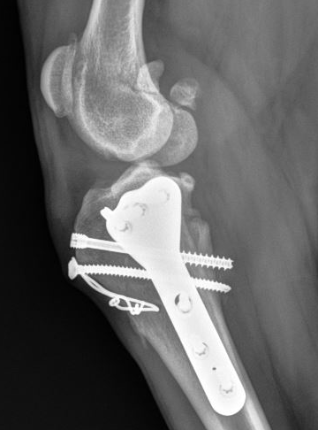
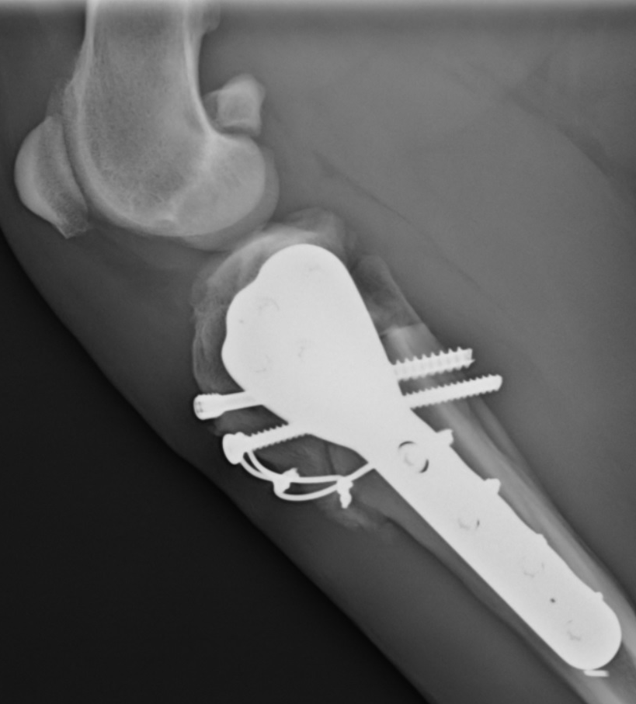

FIGURE 2: Mediolateral radiograph 5 weeks postoperative CBLO stabilized with a bone plate/HCS augmented with a position screw and tension band with no TPA shift and grade 4 healing. Immediate PostTPA 11°; 36 days postoperative FinalTPA 11° and grade 4 (76–100%) healing.
FIGURE 1: Mediolateral radiograph 5 weeks postoperative CBLO stabilized with a bone plate/HCS augmented with a position screw and tension band with no TPA shift and grade 3 healing. Immediate PostTPA 9°; 33 days postoperative FinalTPA 9° and grade 3 (51-75%) healing.

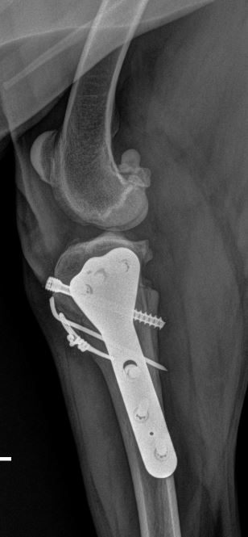
FIGURE 3: Mediolateral radiograph 5 weeks postoperative CBLO stabilized with a bone plate/HCS augmented with a Kirschner wire with no TPA shift and grade 4 healing. Immediate PostTPA 8°; 36 days postoperative FinalTPA 8° and grade 4 (76–100%) healing.

